Operational Research: Semester 2 - Tutorial 1
  - Flow Shop Scheduling

Johnson’s Rule
  - List the jobs.
  - Select the job with the shortest activity time, break ties arbitrarily.
    - If shortest is for first activity, schedule as early as possible.
    - Else if shortest is for second activity, schedule as late as possible.
  - Remove the job from list.
  - Repeat 2 and 3 until no jobs are left to schedule.

Example
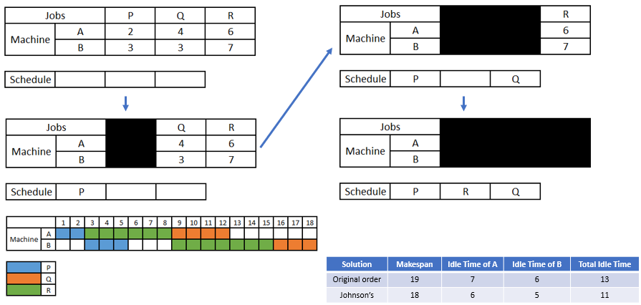

Determining Makespan via Network
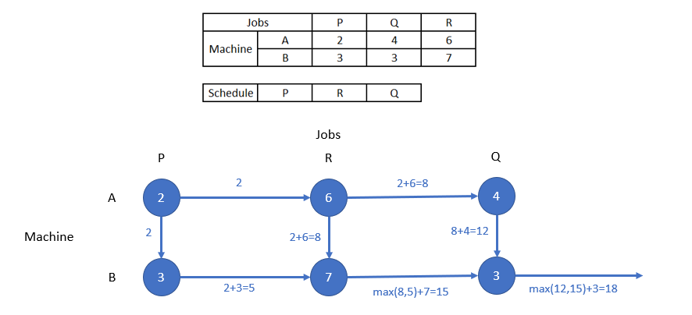

Exercises

- Use Johnson’s Rule to determine the optimal production schedule for the following problem
  - Draw a Gantt Chart displaying the jobs on the given machines.
  - Calculate the minimum Makespan
  - Calculate the idle times for the machines and therefore the total idle time

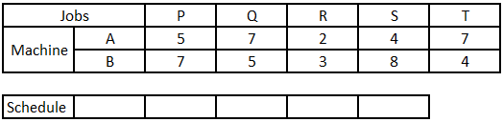

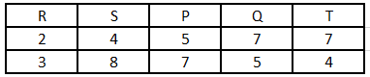

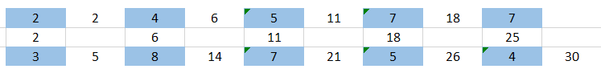

Makespan – 30

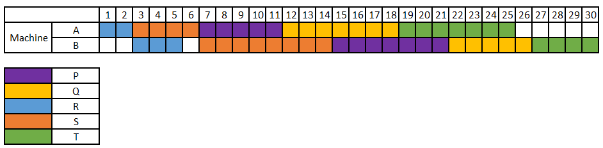

Idle time on A – 5
Idle time on B - 3
Total - 8

- Use Johnson’s Rule to determine the optimal production schedule for the following problem
  - Calculate the minimum Makespan via a network representation

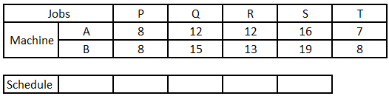

Depending on how you choose to schedule P, either at the beginning or the end…

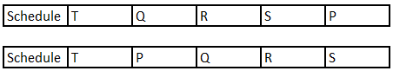

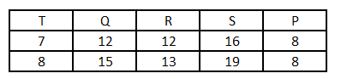

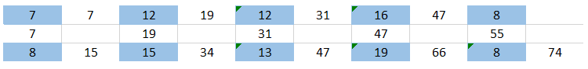

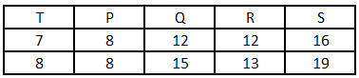

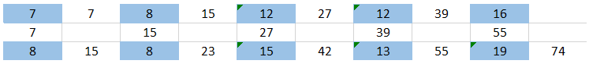

- By applying Johnson’s Rule determine a good production schedule for the following problem and compare this to the original order solution. To do the comparison you will need to compute the Makespan of both the original order and your solution, this would make a good exercise on to try on Excel…

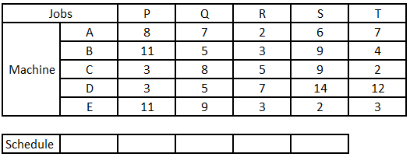

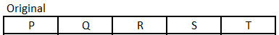

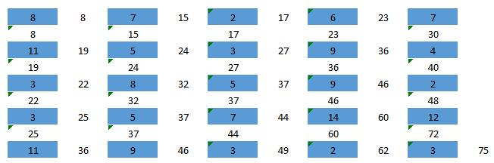

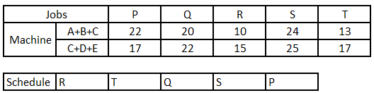

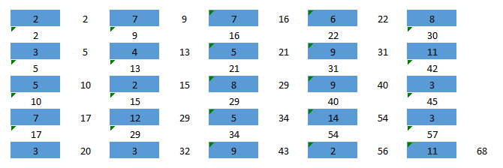

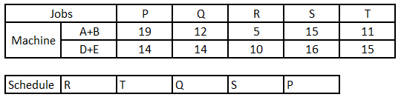

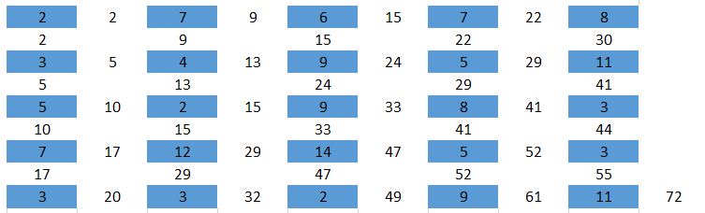

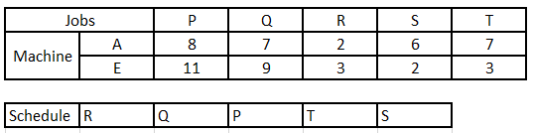

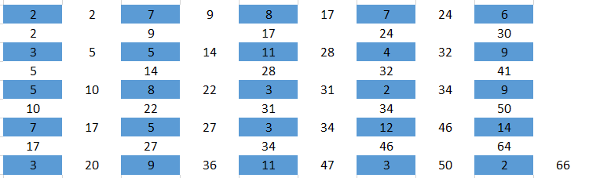

Best known order is 66 given by Johnson’s Rule and the Campbell, Dudek and Smith heuristic.
Machines A and E considered.
RQPTS

